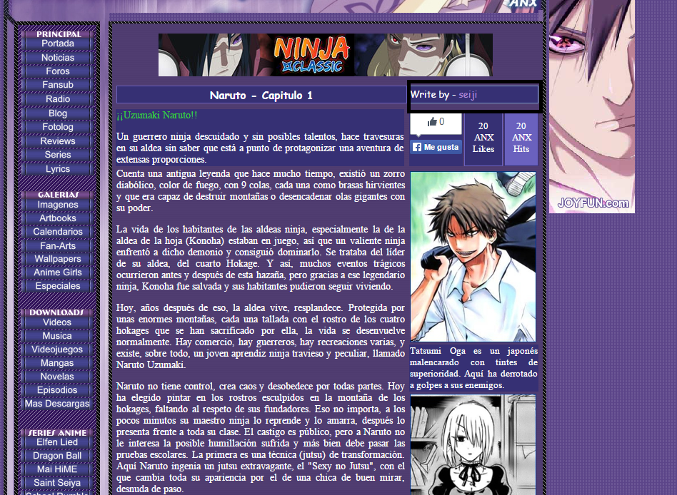
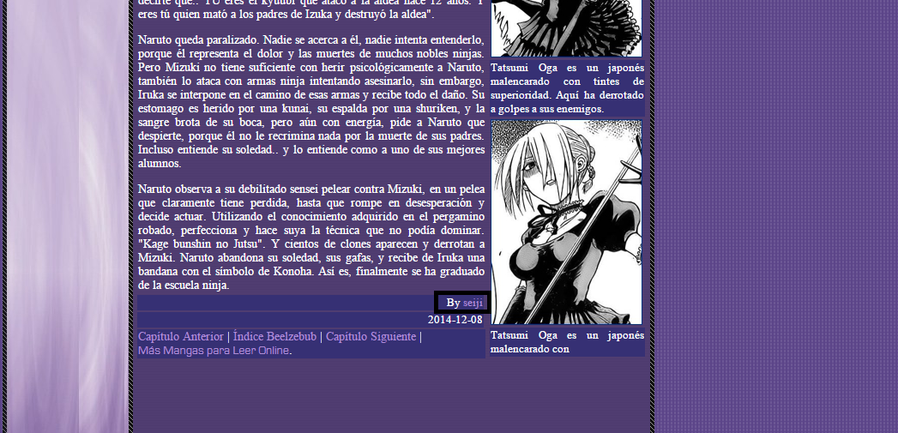
--This links (ANXWriter) have to link to the user profile.
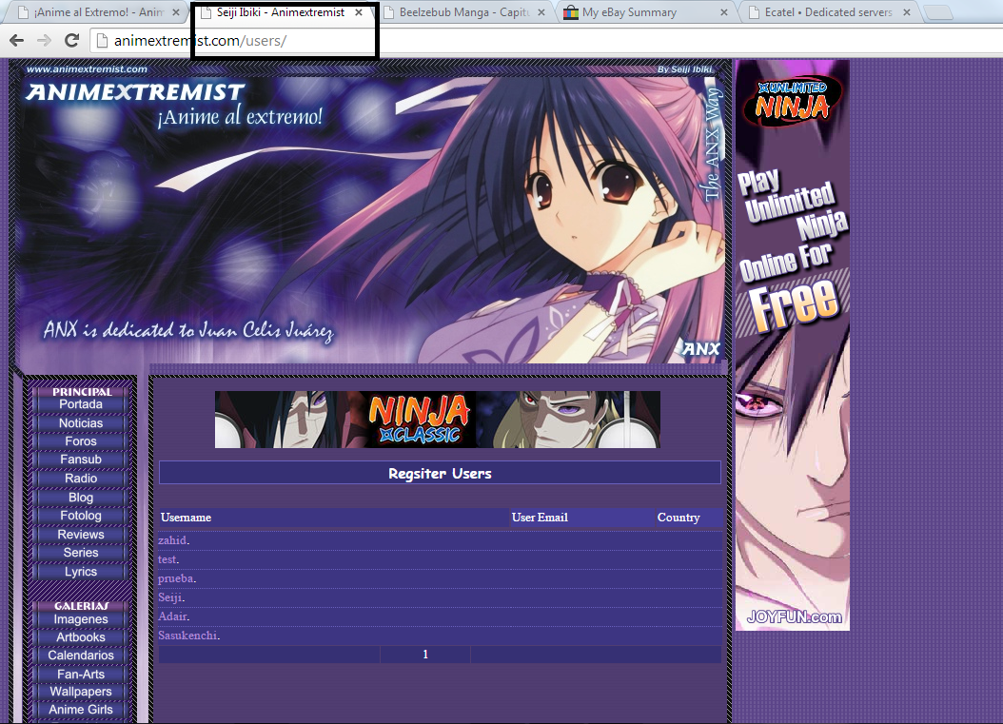
--The Header of the users page says: Seiji Ibiki – Animextremist.
--It should this structure: ANX Users – Animextremist
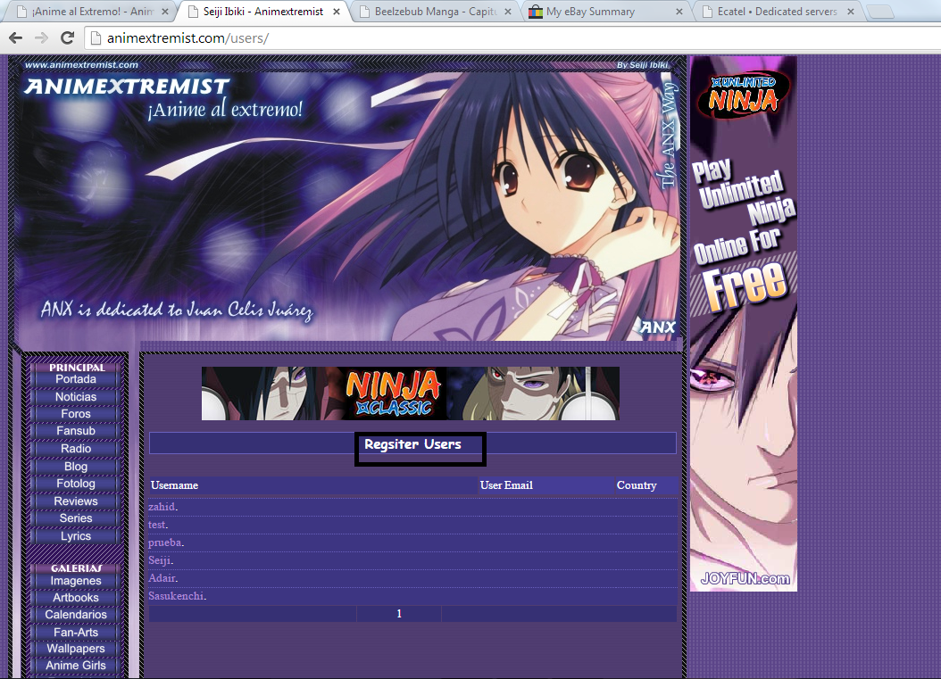
--It should be – Usuarios Registrados.
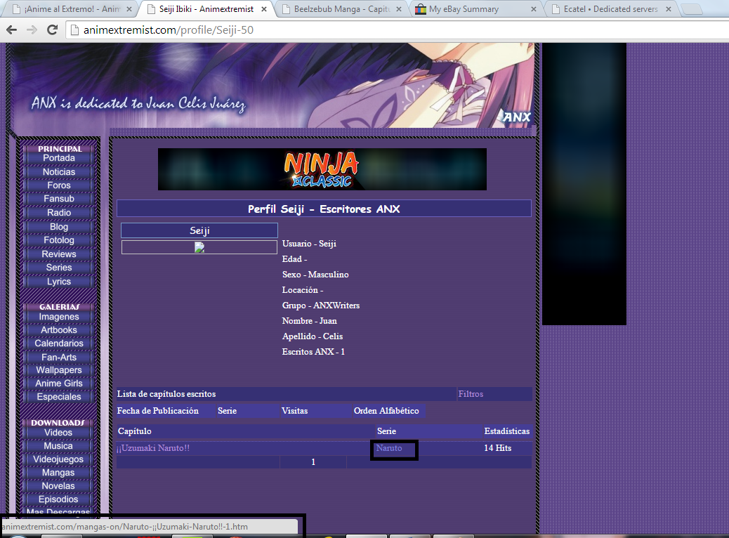
--This should link to the serie index. In this example should link to http://www.animextremist.com/naruto-manga.htm
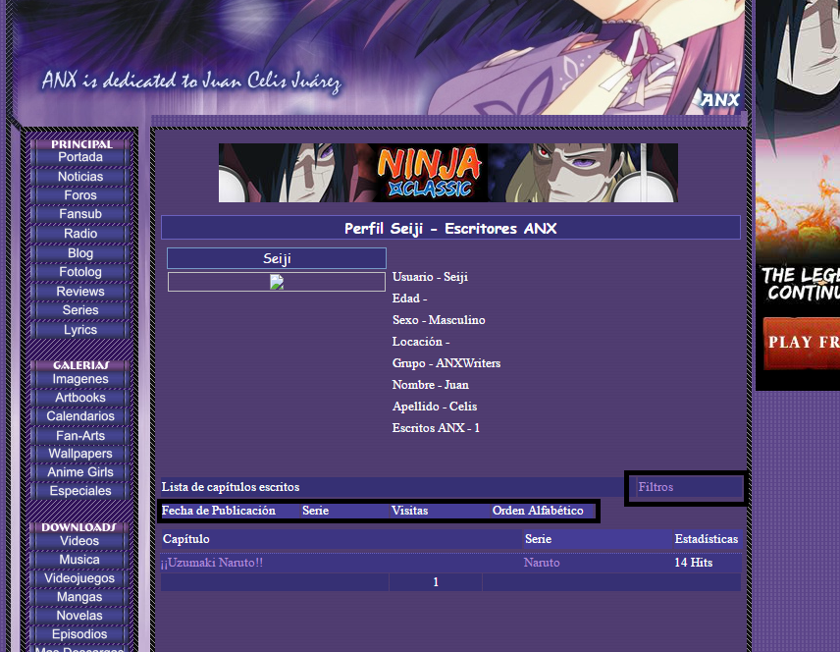
--This Filters (“Filtros”) are actually not working. It should filter the list by:
--Date – “Fecha de publicación”.
--Serie – Serie.
--Alphabetic order – “Orden Alfabético”.
--Filters should load with AJAX, I mean, load on the same page.
--Please delete “visitas” and “Estadísticas” fields for the moment.
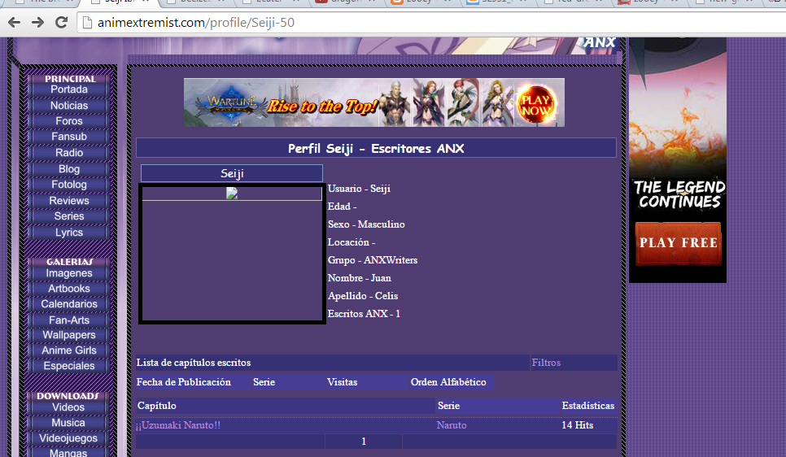
--The avatar should be loading if the user has a Avatar on the forum, but if not, should load a default avatar. Any URL/Folder where I can upload a Default avatar should be OK.
--Whats the meaning of the URL structure – profile/Seiji-50?
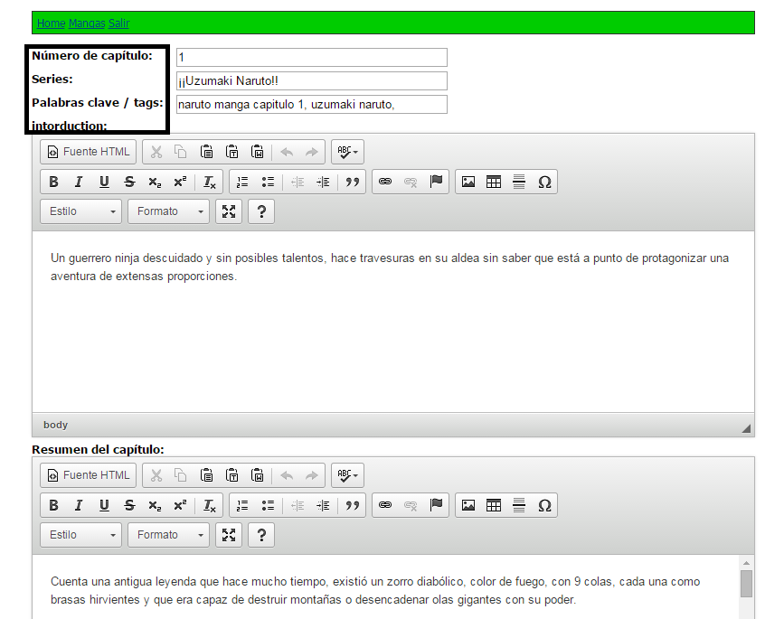
--This is a translation issue. Nothing bad, but please edit this four fields:
--Número de capítulo: - That’s OK.
--Series – That Should be – Nombre del capítulo.
--Palabras clave /tags: - That’s OK.
--Intorduction – That Should be – Introduccion.
We have still to check the index serie (Please read the document and check this: http://www.animextremist.com/beelzebub-manga.htm). We talk about that tomorrow.

