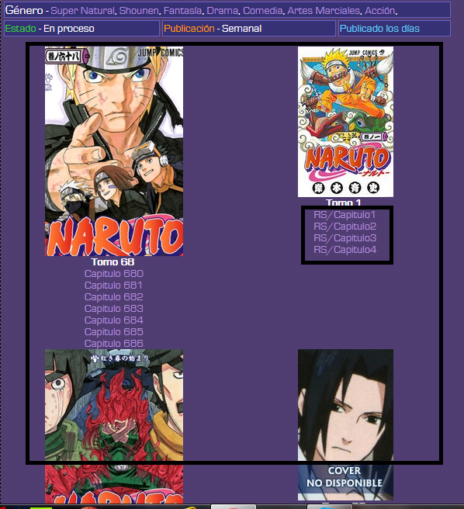
Here the system doesnt show the tomos in order. It should show tomo 1, tomo 2, tomo 3, etc, etc, in that order, not tomo 68, tomo 1, tomo 58, etc. The order list parameter is Not creation date, is order by numbering.
Secondly, the (RS) chapters have a wrong link, please check that, also, is RS/Capitulo 1, Not RS/Capitulo1.
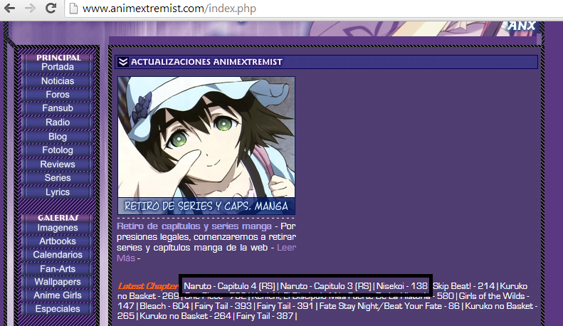
In the index page, we have an issue. The Lastest Chapter List is just showing the last 2 resumes that I create, nevermind if I just create 4 of them the same day. Please check this.
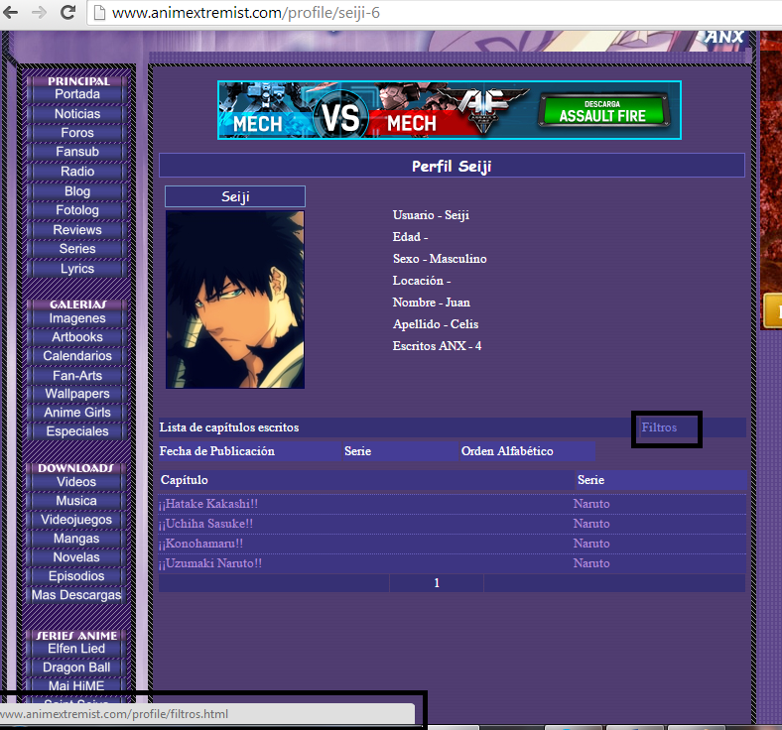
In this profile, Filtros have this odd link (profile/filtros.html) when in fact it doesnt have to show any link at all. Please delete this Filtros button (as this button wasn’t crate as I want and declare in the first project) and just leave the filters list itself – Fecha de Publicación, Serie, Orden Alfabético.
Also, the user info should be posted more close to the image. See the link http://www.animextremist.com/mangas-online/beelzebub/capitulo-2/usuario.html

